Agricultural Revenue: Description and Documentation

Key outcome name: Agricultural Revenue

Authors: Armen Konialian¹, Josue Medellin-Azuara² and Alvar Escriva-Bou^{3*}
*Corresponding author: Alvar Escriva-Bou, aescriva@ucdavis.edu
¹ Department of Civil and Environmental Engineering, University of California, Los Angeles
² Department of Civil and Environmental Engineering, University of California, Merced
³ Department of Civil and Environmental Engineering, University of California, Davis

Background
The Central Valley is home to one of the world's most productive agricultural regions, producing more than 300 agricultural commodities across over 6.5 million acres and supporting hundreds of thousands of jobs. Reliable water supplies are essential to sustaining this agricultural sector and the communities that depend on it.
Farmers rely on a combination of surface water and groundwater to meet their irrigation needs. Surface water is delivered primarily through an extensive network of reservoirs, canals, and conveyance infrastructure operated by local, state, and federal agencies. Groundwater is also a critical source of supply throughout the Central Valley, often used in conjunction with surface water to improve reliability, but in many areas serving as the sole source of irrigation water.
While surface water deliveries and groundwater availability are primary drivers of agricultural production, regional economic activity is also shaped by crop characteristics, soil and climate conditions, and farmers' management decisions, among other factors. Differences in crop mix and in producers' ability to adapt to water shortages lead to substantial variation in how regions experience the economic impacts of reduced water supplies.
To assess the impacts of water availability on the agricultural sector, we use agricultural revenue as the key outcome metric. Agricultural revenue is commonly used as an indicator of agricultural productivity. This metric captures both production processes and farmers' management decisions by explicitly reflecting the crop mix across regions, while also accounting for adaptive responses to water shortages, such as prioritizing the production of certain crops during droughts.
Estimating agricultural revenue under alternative scenarios requires linking multiple models and adopting several key assumptions. First, we use CalSim3 outputs to estimate surface water and groundwater deliveries to agricultural demand units (DUs)—agricultual regions that share common water supplies—that represent the Locations of Interest (LOIs) in COEQWAL. These water deliveries are compared with baseline water supplies to quantify water shortages—that is, periods when available supplies fall short of demand and farmers must adjust their production decisions. The estimated shortages are then provided as inputs to OpenAg, an agricultural production model that simulates farmers' decision-making in response to changing water availability. OpenAg estimates the resulting crop mix over time as a function of water supply conditions and produces corresponding estimates of agricultural revenue, along with other agricultural and economic outcomes.
In the following sections we describe and show first the locations of interest, then we explain the methodology in detail, to later present the key outcome levels, and finally explain the guidelines for implementation.

Locations of Interest
There are 134 locations of interest (LOIs) representing the agricultural demand units evaluated in this study. Of these, 73 are in the Sacramento Basin, 58 in the San Joaquin Basin, and 3 in the Tulare Basin.
The accompanying figure and table identify the agencies represented by each location of interest, the basin in which it is located, and whether the demand unit has groundwater and surface water supplies.
South of the San Joaquin hydrologic region, many users in the Tulare Basin and agencies in Southern California such as Metropolitan Water District of Southern California, are represented through surface water delivery nodes (called “diversion nodes” in CalSim3). In these cases, groundwater pumping and other components of the users’ broader water supply portfolios are not explicitly represented, unlike the more comprehensive demand unit representation used elsewhere in the model. Thus, they are not part of this analysis.
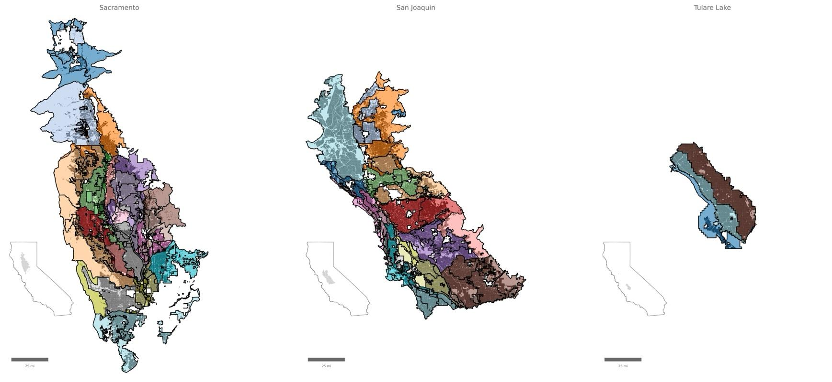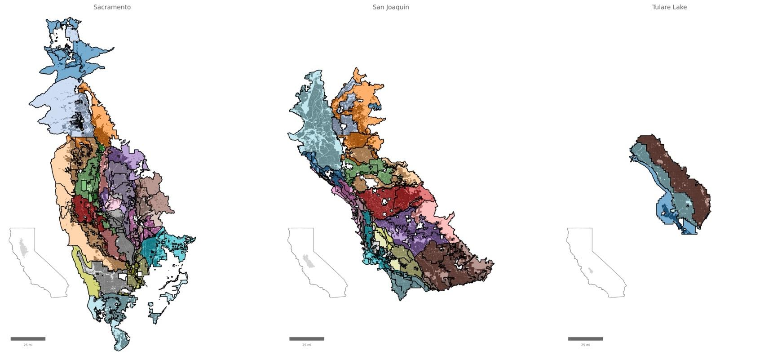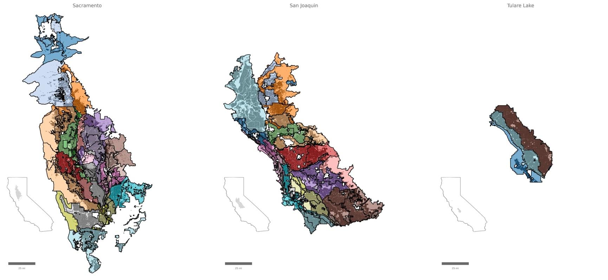
Figure 1: Map showing the LOIs (or Demand Units) for the three hydrologic regions. In darker color within the LOIs, we show the actual irrigated acreage.
Table 1: Water agencies, water supply sources and hydrologic region for each Location of Interest.
Location of Interest | Water District or Agency | GW | SW | Basin
02_NA | Non-district | • | • | Sacramento
02_SA | Anderson-Cottonwood ID, misc. settlement contractors | • | • | Sacramento
02_PA | Clear Creek CSD | • | • | Sacramento
03_NA | Non-district | • | • | Sacramento
03_SA | Anderson-Cottonwood ID, misc. settlement contractors | • | • | Sacramento
03_PA | Bella Vista WD | • | • | Sacramento
04_NA | Non-district including misc. settlement contractors | • | • | Sacramento
04_PA1 | Corning WD, Proberta WD, Thomes Creek WD | • | • | Sacramento
04_PA2 | Kirkwood WD | • | • | Sacramento
05_NA | Los Molinos MWC, non-district including misc. CVP settlement contractors | • | • | Sacramento
06_NA | Non-district | • | - | Sacramento
06_PA | Orland Unit WUA | • | • | Sacramento
07N_NA | Non-district | • | - | Sacramento
07N_PA | Glide WD, Holthouse WD (65% of total), Kanawha WD, Orland-Artois WD | • | • | Sacramento
07S_NA | Non-district | • | - | Sacramento
07S_PA | 4-M WD, Colusa County WD, Cortina WD, Davis WD, Dunnigan WD, Glenn Valley WD, Holthouse WD (35% of total), La Grande WD, Myers-Marsh MWC, Westside WD | • | • | Sacramento
08N_NA | Non-district | • | • | Sacramento
08N_PA | Colusa Drain MWC (8% of total) | • | • | Sacramento
08N_SA1 | Maxwell ID (5% of total), Princeton-Codora-Glenn ID, Provident ID, misc. settlement contractors | • | • | Sacramento
08N_SA2 | Glenn-Colusa ID (55% of total) | • | • | Sacramento
08S_NA1 | Non-district | • | • | Sacramento
08S_NA2 | Non-district | • | • | Sacramento
08S_PA | Colusa Drain MWC (70% of total) | • | • | Sacramento
08S_SA1 | Maxwell ID (95% of total), Sycamore Family Trust, misc. settlement contractors | • | • | Sacramento
08S_SA2 | Glenn-Colusa ID (45% of total) | • | • | Sacramento
08S_SA3 | RD 108, River Garden Farms, misc. settlement contractors | • | • | Sacramento
09_NA | Llano Seco Ranch (formerly Parrot Ranch), Dayton MWC, non-district | • | • | Sacramento
09_SA1 | Pacific Realty Associates (formerly M&T Chico Ranch) | • | • | Sacramento
09_SA2 | RD 1004, Carter MWC, Jack Baber, misc. settlement contractors | • | • | Sacramento
10_NA | Rancho Esquon, Durham MWC, non-district | • | • | Sacramento
11_NA | Sutter Butte MWC, non-district | • | • | Sacramento
11_SA1 | Western Canal WD | • | • | Sacramento
11_SA2 | Richvale ID | • | • | Sacramento
11_SA3 | Biggs-West Gridley WD, Butte WD | • | • | Sacramento
11_SA4 | Sutter Extension WD | • | • | Sacramento
12_NA | Non-district | • | • | Sacramento
12_SA | Misc. FRSA diverters | - | • | Sacramento
13_NA | South Feather Water and Power Agency, Yuba County WD | • | • | Sacramento
 | Non-district | • | - | Sacramento
14_NA | Browns Valley ID | • | • | Sacramento
15N_NA1 | Non-district | • | - | Sacramento
15N_NA2 | Cordua ID, Hallwood ID, Ramirez WD | • | • | Sacramento
15N_SA | Misc. FRSA diverters | - | • | Sacramento
15S_SA | Plumas MWC, misc. FRSA diverters | • | • | Sacramento
15S_NA1 | Non-district | • | - | Sacramento
15S_NA2 | Brophy WD, Dry Creek MWC, South Yuba WD, Wheatland WD | • | • | Sacramento
16_NA1 | Non-district | • | - | Sacramento
16_NA2 | Non-district | • | - | Sacramento
16_PA | Feather WD | • | • | Sacramento
16_SA | Garden Highway MWC, Tudor ID, Oswald WD, misc. FRSA diverters | • | • | Sacramento
17N_NA | Non-district | • | - | Sacramento
17S_NA | Non-district | • | • | Sacramento
 | Sutter Bypass-Butte Slough WUA | • | • | Sacramento
17S_SA | Misc. FRSA diverters and minor settlement contractors | • | • | Sacramento
18_NA | Butte Slough Irrigation Company, Sutter Butte MWC, non-district | • | • | Sacramento
18_SA | Meridian Farms WC, Lomo Cold Storage, Sutter MWC (5%), Tisdale IDC, misc. settlement contractors | • | • | Sacramento
19_SA | Bardis et al., Pelger MWC, Sutter MWC (95% of total), misc. settlement contractors | • | • | Sacramento
20_NA1 | Yolo County FC&WCD | • | • | Sacramento
20_NA2 | Non-district | • | - | Sacramento
20_PA | University of California, Davis | • | • | Sacramento
21_NA | Non-district | • | • | Sacramento
21_PA | Colusa Drain MWC (22% of total) | • | • | Sacramento
21_SA | Conaway Conservancy Group, misc. settlement contractors | • | • | Sacramento
22_NA | Non-district | • | • | Sacramento
22_SA1 | Natomas Central MWC, Pleasant Grove-Verona MWC, misc. settlement contractors | • | • | Sacramento
22_SA2 | Misc. FRSA diverters | - | • | Sacramento
23_NA | Camp Far West ID, South Sutter WD, non-district | • | • | Sacramento
24_NA1 | Nevada ID | • | • | Sacramento
24_NA2 | Placer County WA Zone 5, non-district | • | • | Sacramento
24_NA3 | Placer County WA Zone 1 | • | • | Sacramento
25_NA | North Delta WA, non-district | • | • | Sacramento
25_PA1 | Solano ID (77% of total) | • | • | Sacramento
25_PA2 | Maine Prairie WD | • | • | Sacramento
26N_NA | Non-district | • | - | Sacramento
26S_NA | Non-district | • | - | Sacramento
50_PA1 | Banta-Carbona ID | • | • | San Joaquin
 | West Side ID | • | • | San Joaquin
50_PA2 | Byron-Bethany ID (excluding former Plainview ID service area) | - | • | San Joaquin
60N_NA1 | Jackson Valley ID | • | • | San Joaquin
60N_NA2 | Omochumne-Hartnell WD, Clay WD, Galt ID | • | • | San Joaquin
60N_NA3 | North San Joaquin WCD | • | • | San Joaquin
60N_NA4 | Woodbridge ID, Woodbridge Users Association | • | • | San Joaquin
60N_NA5 | Non-district, riparian diverters | • | • | San Joaquin
60S_NA1 | Non-district east | • | - | San Joaquin
60S_NA2 | Non-district west | • | - | San Joaquin
60S_PA1 | Stockton East WD | • | • | San Joaquin
60S_PA2 | Central San Joaquin WCD | • | • | San Joaquin
61_NA1 | Non-district east | • | - | San Joaquin
61_NA2 | Modesto ID | • | • | San Joaquin
61_NA3 | Non-district, Tuolumne River riparian right bank diverters | • | • | San Joaquin
61_NA4 | Non-district, Stanislaus River riparian diverters | • | • | San Joaquin
61_NA5 | Non-district, San Joaquin River riparian diverters between Tuolumne and Stanislaus rivers | • | • | San Joaquin
61_NA6 | Non-district, San Joaquin River riparian diverters downstream from Stanislaus River confluence | • | • | San Joaquin
61_PA1 | Oakdale ID north | • | • | San Joaquin
61_PA2 | Oakdale ID south | • | • | San Joaquin
61_PA3 | South San Joaquin ID | • | • | San Joaquin
62_NA1 | Non-district east | • | - | San Joaquin
62_NA2 | Non-district, Merced River riparian right bank diverters | • | • | San Joaquin
62_NA3 | Turlock ID | • | • | San Joaquin
62_NA4 | Non-district, Tuolumne River riparian left bank diverters | • | • | San Joaquin
62_NA5 | Non-district, San Joaquin River riparian diverters between Merced and Tuolumne rivers | • | • | San Joaquin
62_NA6 | Merced ID (3.5% of total, north of Merced River) | • | • | San Joaquin
63_NA1 | Non-district east | • | - | San Joaquin
63_NA2 | Non-district, Merced riparian left bank diverters | • | • | San Joaquin
63_NA3 | Merced ID (96.5% of total, south of Merced River) | • | • | San Joaquin
63_NA4 | Non-district West, Plainsburg ID, La Grande-Athlone WD, Turner Island WD, Stevinson WD, Merced River riparian diverters | • | • | San Joaquin
63_NA5 | El Nido ID | • | • | San Joaquin
64_NA1 | Non-district east | • | - | San Joaquin
64_NA2 | Non-district west | • | • | San Joaquin
64_PA1 | Madera ID, Madera WD | • | • | San Joaquin
64_PA2 | Chowchilla WD | • | • | San Joaquin
64_PA3 | Gravelly Ford WD, Root Creek WD | • | • | San Joaquin
64_XA | Columbia Canal Company | • | • | San Joaquin
71_NA1 | Non-district San Joaquin River riparian diverters (Orestimba Creek to Del Puerto Creek) | • | • | San Joaquin
71_NA2 | El Solyo WD and non-district San Joaquin River riparian diverters (Del Puerto Creek to Vernalis) | • | • | San Joaquin
71_NA3 | Non-district | • | - | San Joaquin
71_PA1 | Hospital WD | • | • | San Joaquin
71_PA2 | West Stanislaus ID | • | • | San Joaquin
71_PA4 | Patterson ID | • | • | San Joaquin
71_PA5 | Del Puerto WD, Salado WD, Orestimba WD, Sunflower WD | • | • | San Joaquin
71_PA6 | Davis WD, Foothill WD, Mustang WD, Quinto WD, Romero WD, Centinella WD | • | • | San Joaquin
71_PA7 | Oak Flat WD | • | • | San Joaquin
71_PA8 | Byron-Bethany ID (area which was formerly Plainview ID) | • | • | San Joaquin
72_NA1 | Non-district San Joaquin River riparian diverters (Mud Slough to Orestimba Creek) | • | • | San Joaquin
72_NA2 | Non-district | • | - | San Joaquin
72_PA | Laguna WD | • | • | San Joaquin
72_XA1 | San Luis Canal Company | • | • | San Joaquin
72_XA2 | Central California ID south | • | • | San Joaquin
72_XA3 | Central California ID north | • | • | San Joaquin
73_NA | Non-district | • | - | San Joaquin
73_PA1 | San Luis WD north | • | • | San Joaquin
73_PA2 | Eagle Field WD, Mercy Springs WD, Oro Loma WD | • | • | San Joaquin
73_PA3 | Pacheco WD | • | • | San Joaquin
 | Pacheco WD | • | • | San Joaquin
 | San Luis WD south | • | • | San Joaquin
73_XA | Firebaugh Canal WD | • | • | San Joaquin
90_PA1 | Westlands WD Priority Area I, DD No. 2 | • | • | Tulare
90_PA2 | Westlands WD Priority Area II, DD No. 1, No. 3 | • | • | Tulare
91_PA | Coelho Family Trust, Fresno Slough WD, James ID, RD 1606, Tranquility ID, Tranquility PUD | • | • | Tulare
For each of these LOIs we use the 2020 Statewide Crop Dataset developed by LandIQ to calculate the specific acreage for each crop. This data is used to estimate agricultural revenue.

Methodology
Estimating agricultural revenue involves three main steps. First, we obtain surface water and groundwater deliveries to the LOIs (described above) from CalSim3. Second, we estimate water shortages – that is, periods when water deliveries are insufficient to meet demand – for each LOI. Finally, using the resulting water deliveries and shortages, we estimate agricultural revenue for each region using OpenAg. The following subsections describe each step in greater detail.

Estimating Water Deliveries
CalSim3 provides monthly surface and groundwater deliveries for each LOI. As we will show later, OpenAg – the agricultural production model used for the assessment of agricultural revenue – only needs annual deliveries and shortages, so we aggregate monthly deliveries to annual water deliveries.
In the following figure (Figure 2), we show the overall surface vs groundwater supply reliance for each LOI in the map on the left, calculated as the average annual deliveries (from one or other source) with respect to the total deliveries. As we can see, some LOIs are mostly reliant on surface water, others have a mix of surface and groundwater supplies in their portfolio, while some other LOIs are mostly or exclusively reliant on groundwater.
Importantly, deliveries in CalSim3 change annually. First, agricultural demands are influenced by temperature (or evapotranspiration) and precipitation. Wetter years tend to have lower agricultural demands (as some of the water comes directly from precipitation), while hotter years result in increased crop demands and need greater applied water. Second, in CalSim3, surface supplies vary to represent water availability and operation rules in the Central Valley. That means that during drier years, surface water supplies will be reduced—this reduction will be more acute for those users with junior water rights, or less seniority. A key assumption in CalSim3 is that agricultural demands are met even in these drier years by increasing groundwater pumping. Therefore, as shown in the three LOI examples on the right of Figure 2, when surface deliveries decline because of droughts, groundwater deliveries will increase, mitigating all potential shortages.
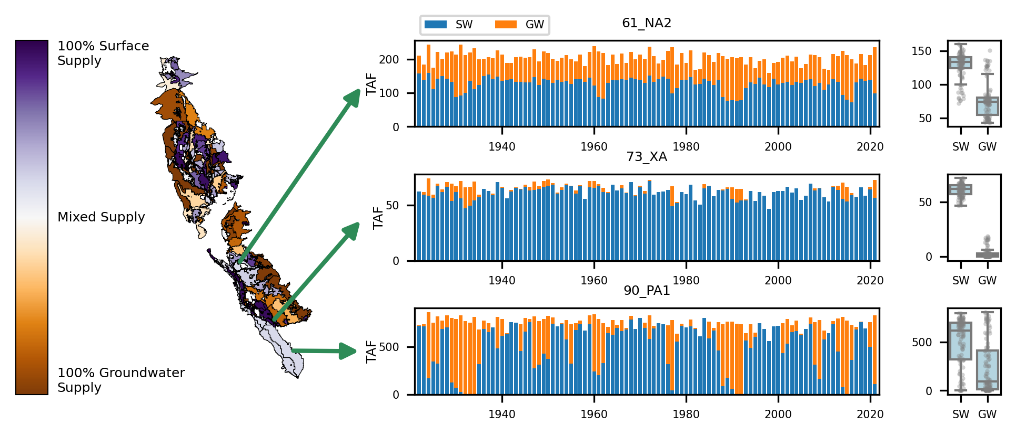Figure 2. Spatial distribution of water supply reliance across demand units (left). Darker purple shades indicate greater reliance on surface water, while darker brown shades indicate stronger dependence on groundwater. Selected examples of LOIs (right) illustrate historical variability in surface water (SW) and groundwater (GW) supplies for representative demand units, highlighting differences in supply composition and variability over time.

While groundwater pumping generally increases during droughts, agricultural users are not always able to fully compensate for reduced surface water deliveries through groundwater pumping alone. During severe drought periods, groundwater limitations and economic constraints can force farmers to fallow land and reduce production, resulting in economic losses (Lund et al., 2018; Medellín-Azuara, 2022; Medellín-Azuara et al., 2016). At this stage, shortages experienced by individual users are not directly represented within the CalSim3 model, representing an important limitation.

Estimating Water Shortages
To overcome this limitation, we estimate water shortages as reductions in surface water deliveries with respect to normal year deliveries under conditions where groundwater pumping increases to compensate for reduced deliveries with respect to total demands. When surface water deliveries fall below what would be considered normal (i.e., non-drought) conditions and groundwater pumping exceeds typical levels, the increase in groundwater pumping is interpreted as evidence that users are compensating for reduced surface water supplies, thereby indicating a surface water shortage. The second condition, the increase in groundwater pumping, is an important condition because in years with lower demands (for instance during wet years) surface deliveries might decrease without any pumping increase. Following our assumption, this does not represent a shortage, just a reduction in demands.
Mathematically, to represent the full level of available surface supply for non-drought years, a benchmark for surface-water deliveries is defined as the 75th percentile of surface deliveries – or “net diversion” in CalSim3 language. We prefer to use the 75th percentile instead of the maximum value because the latter may reflect deliveries during exceptionally wet years, which would overstate the typical level of available surface supply. In addition, groundwater pumping must exceed its median level (50th percentile) for a year with reduced surface deliveries to be classified as a shortage. The median pumping level represents normal groundwater use, as many users rely on groundwater for a baseline share of their supply even during non-drought years. An example of this classification is shown in Figure 3.
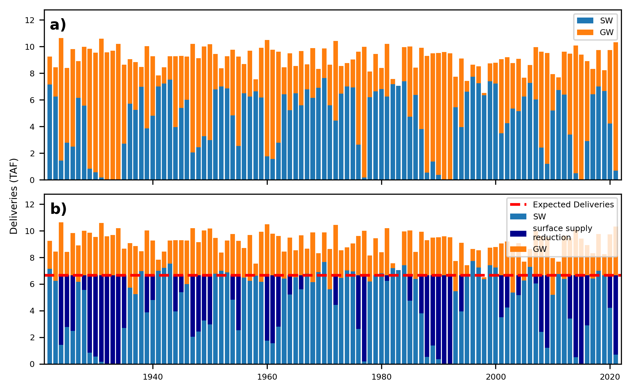
Figure 3. Example of a demand unit with a mixed surface water and groundwater supply. (a) annual surface water deliveries (SW, light blue) and groundwater pumping (GW, orange) derived from Calsim3. (b) The same demand unit after applying surface supply reductions. The red line represents the 75th percentile benchmark of surface-water deliveries used to define non-shortage surface supply levels. The dark-blue portion represents the surface supply reduction relative to the benchmark (interpreted as shortage).
The final shortage will be obtained as the ratio of the reduction in surface supplies with respect to the total water demands—obtained as initial total supplies from surface and groundwater.
$Shortage (\%) = \frac{Δ(SW)}{D} = \frac{Δ(SW)}{SW + GW}$
Where:
- ΔSW = surface supply reduction
- SW = surface water supply
- GW = groundwater supply
- D = total demand

Estimating Water Shortages under Different Operational and Climate Scenarios
To compare scenarios consistently, expected deliveries are first calculated from the baseline scenario (Scenario 0020) as the sum of surface deliveries and shortages for each year. This represents the level of surface deliveries that would have occurred in the absence of shortages and serves as a reference baseline for comparison across scenarios.
For the alternative operational and climate change scenarios, shortages are identified when surface deliveries fall below the expected delivery baseline and the deficit is compensated through additional groundwater pumping (exceeding 50th percentile of the baseline scenario). This approach allows shortages to be quantified relative to baseline operating conditions while accounting for increased groundwater reliance under more severe drought conditions.
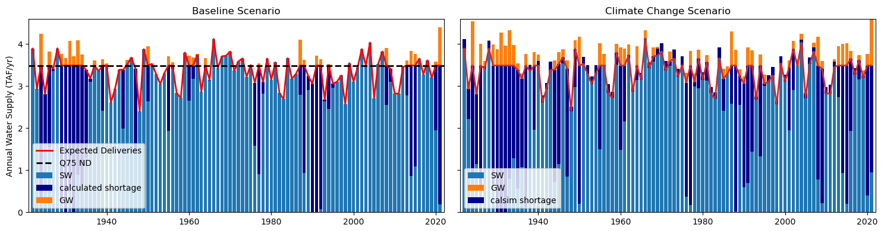
Figure 4: Example of shortage calculation for an alternative scenario. Shortages in new scenarios are calculated as the shortages in the baseline scenario plus the increased shortages caused by the new reductions of surface supplies in the alternative scenario.
Figure 4 shows an example of the level-of-impact (LOI) comparison, contrasting shortage calculations for the baseline scenario against an alternative (climate change) scenario. The left panel shows the baseline scenario, while the right panel shows the alternative scenario. Under the climate change scenario, water demand increases, resulting in two major effects: increased groundwater pumping and reduced surface water deliveries. This pattern is particularly evident during the 2000–2020 period, when drought conditions become more pronounced.
Expected deliveries are first calculated from the baseline scenario and then applied as a reference to the climate change scenario. Any surface deliveries below the baseline delivery levels are classified as a shortage.

Estimating Shortages Under Sustainable Groundwater Management Act (SGMA) Scenarios
For scenarios with reduced groundwater availability, groundwater pumping restrictions are already embedded within CalSim3 operations. As a result, shortages are generated through constrained groundwater availability. To maintain consistency with the shortage definition used in the non-SGMA scenarios, total shortages are defined as the sum of:
- Shortages caused by reductions in surface deliveries relative to expected deliveries
- Shortages resulting from groundwater pumping restrictions
The total estimated shortage is constrained so that it does not exceed the unrestricted groundwater pumping in the absence of SGMA restrictions.
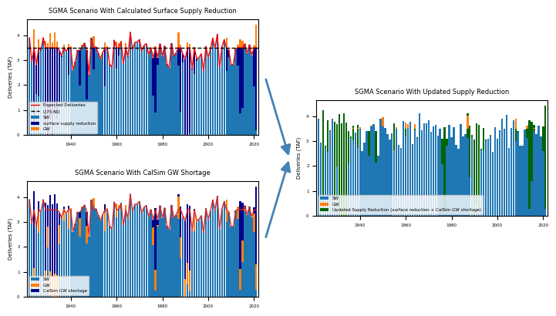
Figure 5: Example workflow for updating supply reduction under SGMA scenarios (right panel) by combining shortages associated with surface delivery reductions (left-top panel) and CalSim3 groundwater shortages (left-bottom panel) into a single shortage estimate while preventing double counting of groundwater-related shortages.
Figure 5 shows how shortages are updated under the SGMA scenario to avoid double counting groundwater-related shortages.
- Top left: shortages associated with reductions in surface deliveries relative to expected deliveries.
- Bottom left: CalSim3 shortages resulting from groundwater pumping restrictions under SGMA.
The updated method shown on the right combines both components while capping the surface delivery reduction by available groundwater pumping. This produces an updated shortage estimate that more consistently represents total unmet supply under SGMA conditions without overstating shortages.

Estimating Agricultural Revenues
The resulting shortage percentages are then used as inputs to OpenAg, an agricultural production model based on Positive Mathematical Programming (Howitt, 1995). OpenAg employs data on land use, production costs, price, yield and applied water to estimate profit-maximizing patterns of crops under varying conditions. Data for these inputs in California are available from various state and federal agencies and University of California studies such as the UC Davis Crop Cost and Return Studies, US Department of Agriculture National Agricultural Statistics Service, and the California Department of Water Resources. We model each LOI as an independent subregion and are able to assess the optimal crop mix and agricultural revenues as a function of water availability – the water shortages calculated in the previous sections.
The agricultural revenues are calculated for each year, based on the annual water availability.

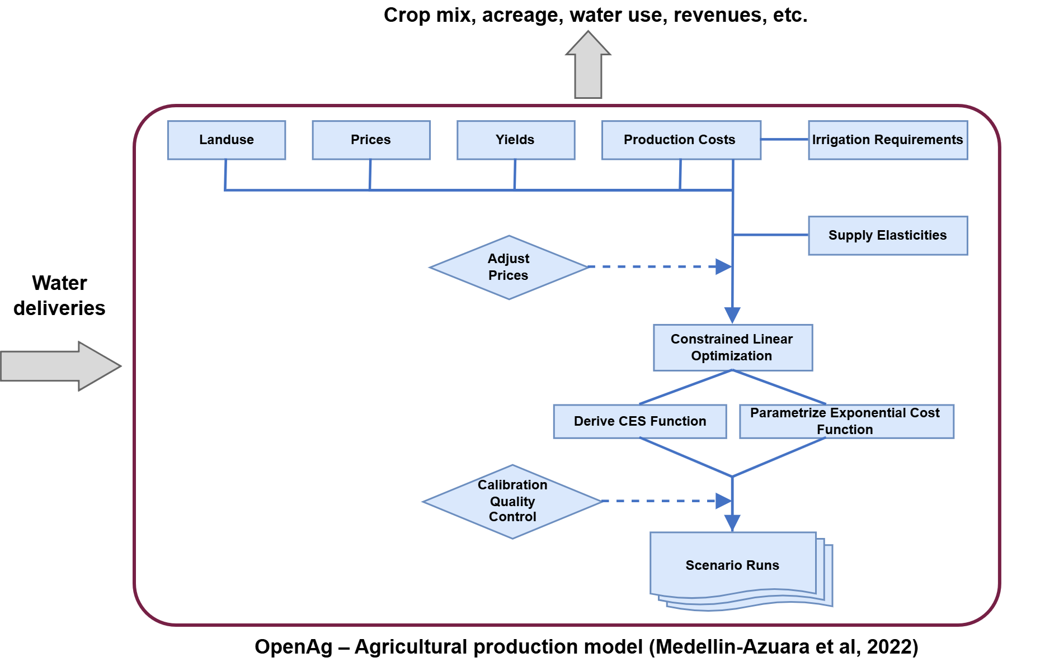
Figure 6. Generalized model flowchart for Positive Mathematical Programming.

Discrete Key Outcome Levels
After obtaining annual revenues, we use the average annual revenues as the key outcome for agricultural production. The key outcome levels correspond to the severity of economic impacts associated with water shortages as represented in Table 2.

Table 2. LOI levels based on agricultural revenue change .
Level 1  Increased revenue | Level 2  Minimal impact | Level 3  Moderate impact | Level 4  Severe impact
Agricultural revenue increases with respect to today's outcomes | Agricultural revenue declines less than 5% with respect to today's outcomes | Agricultural revenue declines 5%-20% with respect to today's outcomes | Agricultural revenue declines more than 20% with respect to today's outcomes

Figure 7 showcases the distribution of agricultural revenue impacts across California LOIs under the baseline scenario. The left map presents the continuous percentage change in agricultural revenue relative to present-day conditions, while the right map shows the corresponding categorical outcome level classification.
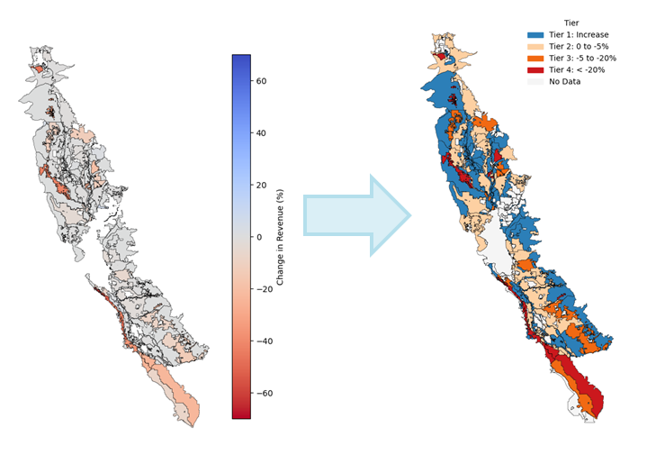
Figure 7: Transformation of continuous agricultural revenue economic impacts into categorical outcome level classifications for the baseline scenario. The left map shows average percentage change in agricultural revenue by demand unit, while the right map shows the corresponding outcome level classification.

Continuous key outcome levels
Continuous key outcome level values are derived from the discrete key outcome levels. For each demand unit, outcome level values within each level are calculated by linearly interpolating the percentage change in agricultural revenue between the upper and lower bounds of that outcome level:
$Continuous Tier(x) = L+\frac{{x_{U}}_{}- x}{{x_{U}}_{}-{x_{L}}_{}}$
where $x$ is the percentage change in agricultural revenue for a given demand unit, $L$ is the discrete outcome level containing $x$, and ${x_{U}}_{}$and ${x_{L}}_{}$are the upper and lower revenue bounds of that level. For Levels 2 and 3, these bounds are fixed by definition: 0% to −5% for Level 2, and −5% to −20% for Level 3. Levels 1 and 4 do not have fixed cutoffs; instead, their bounds are set by the largest revenue increase and decrease observed under the baseline scenario (SC20). As a result, continuous outcome level values range from 1 to 4.99. For example, a demand unit with a 15% decline in agricultural revenue falls within Level 3 (moderate impact, spanning declines of 5% to 20%). Interpolating within this range yields a continuous outcome level value of 3.67, compared to a discrete outcome level of 3, indicating that this demand unit sits toward the more severe end of the moderate-impact category (Figure 8).

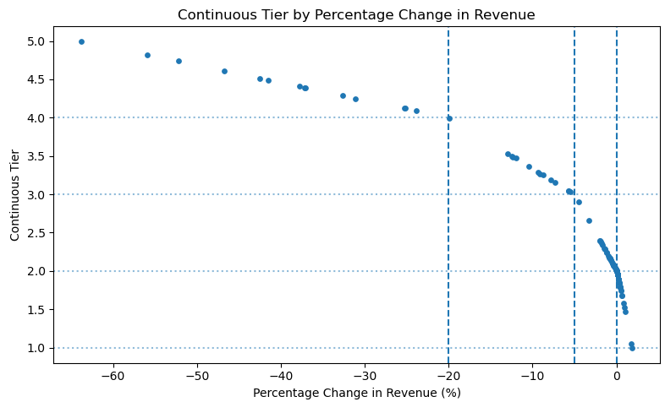
Figure 8. Continuous outcome levels are calculated based on the percentage reduction in average annual revenue.

Guidelines for Interpretation
It is important to clarify that the results represent average economic impacts over the 100-year simulation period rather than impacts associated with individual drought events. Accordingly, the metric should be interpreted as a long-term indicator of economic drought impact rather than a prediction of annual economic outcomes. Using this metric captures both frequency and severity of shortages within a single metric, avoiding the need for separate indicators while maintaining a simpler framework for comparative analysis across demand units and scenarios under the modeled assumptions.
Another important consideration is the definition of shortages used in this study. The shortage metric does not represent actual unmet demands experienced by users, but rather reductions in surface water deliveries relative to total water supply. As a result, shortages are strongly influenced by the composition of users’ water supply portfolios, particularly their dependence on surface water versus groundwater supplies.
Users that rely almost entirely on groundwater supplies may experience little to no modeled shortages because reductions in surface deliveries have limited influence on their total supply portfolio. This was observed during the pre-SGMA period, where groundwater-dependent users experienced limited drought impacts within the framework. In contrast, users that rely heavily on surface water deliveries may experience larger shortages when surface supplies decline substantially during dry periods. However, some surface-water-dependent LOIs possess more senior water rights and therefore experience relatively small reductions in deliveries, resulting in limited shortages despite their dependence on surface water supplies. Similarly, LOIs that primarily depend on groundwater, but also receive supplemental surface deliveries, may experience only minor shortages because groundwater remains their dominant source of supply.
Another caveat is how users are represented through LOIs. Results are evaluated at the LOI (demand unit) scale used in CalSim3, which aggregates multiple agricultural users and regions into larger operational units. Therefore local-scale differences in groundwater access or infrastructure may not be fully captured. In addition, these results cannot be used to determine specific impacts to any one farm or farmer.

Assumptions related to coupling with OpenAg
An important limitation is that an external model is used to estimate agricultural economic activity, meaning that CalSim3 and OpenAg are not fully integrated. While CalSim3 attempts to meet water demands across all years regardless of economic outcomes, OpenAg independently evaluates the economic response to water shortages based on the water deliveries simulated by CalSim3. Therefore, the framework represents a one-way coupling in which CalSim3 outputs inform OpenAg, rather than a dynamically integrated feedback system between hydrologic operations and agricultural economics.
As a result, some differences exist in the underlying assumptions of the two models. For example, in CalSim3, crop water demands vary across years based on hydrometeorological conditions, whereas in OpenAg, agricultural demand assumptions remain fixed across the simulation period.
Another assumption in OpenAg is that it’s a perfect foresight model, meaning that optimization decisions are made with knowledge of the full 100-year simulation period. Future hydrologic conditions are uncertain and cannot be predicted. Consequently, the modeled economic outcomes may represent a more optimistic or best-case adaptation scenario relative to real-world decision-making under uncertainty.
Another limitation is that continuous outcome level values are capped at 4.99 for the baseline scenario. As a result, demand units experiencing economic impacts beyond this threshold are not further differentiated within the framework. Only a limited number of demand units exceed this value, as shown in Figure 9, and therefore it’s not substantially influencing the overall interpretation of results.

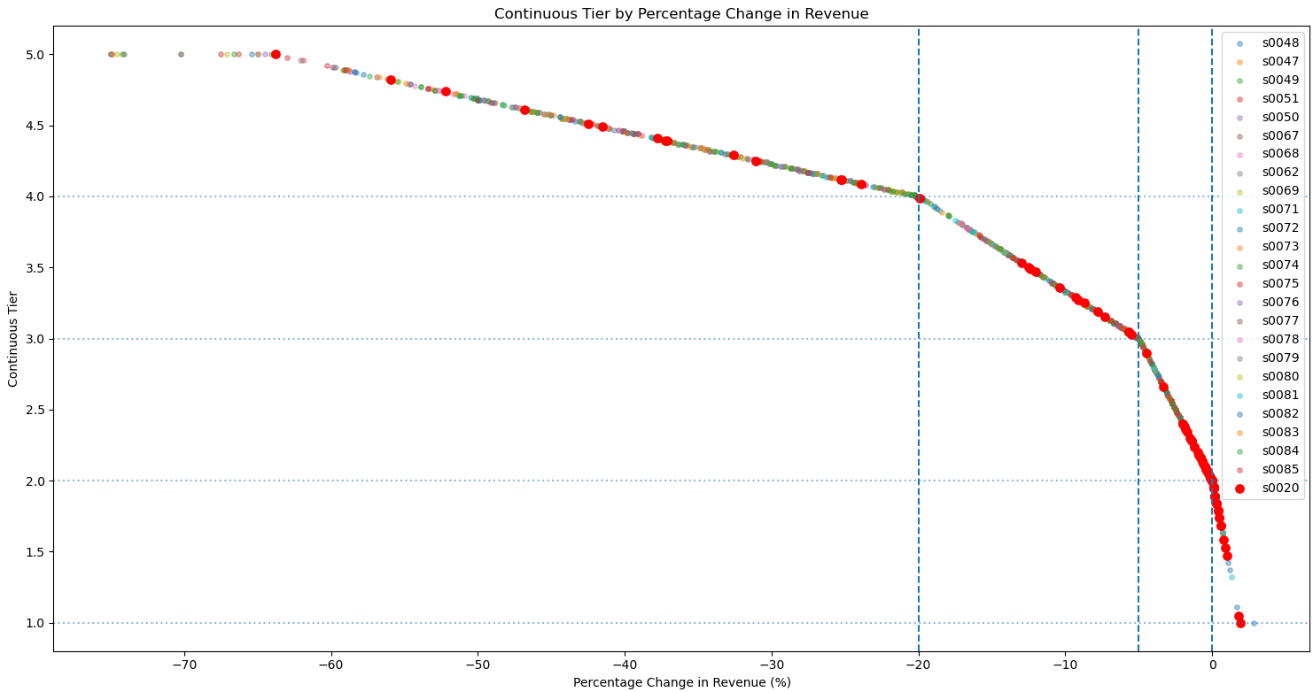
Figure 9. Relationship between average percentage change in agricultural revenue and continuous outcome level values for each LOI under the baseline scenario (SC20). Continuous outcome level values are derived from expected economic impacts over the 100-year simulation period and range from 1 to 4.99, where higher outcome level values represent greater economic impacts. Vertical dashed lines indicate the discrete outcome classification thresholds based on percentage revenue loss, while horizontal dashed lines represent the corresponding continuous outcome ranges. Red markers highlight the baseline scenario values.

References
Howitt, R. E. (1995). Positive mathematical programming. American journal of agricultural economics, 77(2), 329-342.
Lund, J., Medellin-Azuara, J., Durand, J., & Stone, K. (2018). Lessons from California’s 2012–2016 Drought. Journal of Water Resources Planning and Management, 144(10), 04018067. https://doi.org/10.1061/(ASCE)WR.1943-5452.0000984
Medellin-Azuara, J., Escriva-Bou, A., Cole, S.A., Rodriguez-Flores, J.M. Santos, N., Tapia, M. (2023, February 22) OpenAg Hydroeconomic Modeling Hub. https://openag.ucmerced.edu/#/pages/about
Medellín-Azuara, J. (2022, November 22). Economic Impacts of the 2020–22 Drought on California Agriculture.
Medellín-Azuara, J., MacEwan, Howitt, R., Sumner, D., & Lund, J. (2016). Economic Analysis of the 2016 California Drought on Agriculture. UC Davis. https://cawaterlibrary.net/wp-content/uploads/2019/08/DroughtReport_20160812.pdf

CalSim3 does not include all the agricultural acreage in the Central Valley, as an important part of the Tulare Lake hydrologic region is not represented.
Although profits—which account for production costs—can be considered a better proxy for agricultural income and are more closely related to value added, estimates of agricultural costs are substantially less comprehensive and reliable than estimates of revenues. In addition, revenues are more straightforward to interpret and communicate.
Note the CalSim3 Agricultural Demand Units (DUs) and COEQWAL Location of Interest (LOIs) for agriculture are the same spatial units.

